# **How It Works: KINECT-IMU Calibrator Beta1**

**Subtasks**

* Connecting to a Bluetooth device
  + When the application loads it will scan for all devices that are nearby. If your device isn’t there, press <Find Bluetooth Devices>
  + Once connected, one will see the data at the bottom of the screen
* Logging Data that is being collected
  + Connect the Bluetooth devices and connect the KINECT if desired.
  + Browse for the folder location that the data should be saved to
  + After looking at the graphs, numbers, etc. Press <Strat Data Logging>
  + To complete, press <Stop Data Logging>
  + (If you exist the program, the logs are stopped and saved.)
* Binding a Bluetooth device to the *Kinect Default Coordinate System. (This is only for displaying the correct orientation of the IMU cube)*
  + Connect a Bluetooth device.
  + When the device is in the correct orientation, press <Bind To Kinect Default Cord>  
    **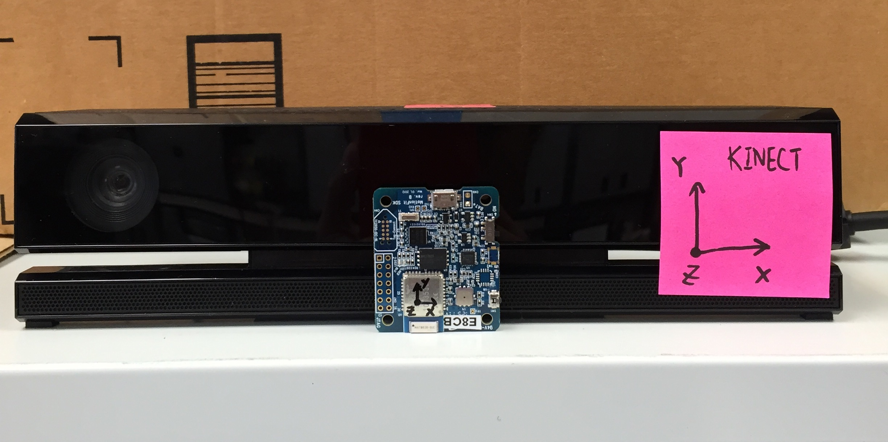  
    Figure1. Correct Orientation of Kinect Default Cord Binding**
* Binding a Bluetooth device to the *Right Arm Quaternion as Read by KINECT*
  + Connect a Bluetooth device
  + Strap device to right wrist
  + Put the wrist in the identity orientation (Right hand pointed to the ceiling, hand open, thumb away from Kinect )
  + When the device is in the correct orientation, press <Bind To Right Forearm>
  + 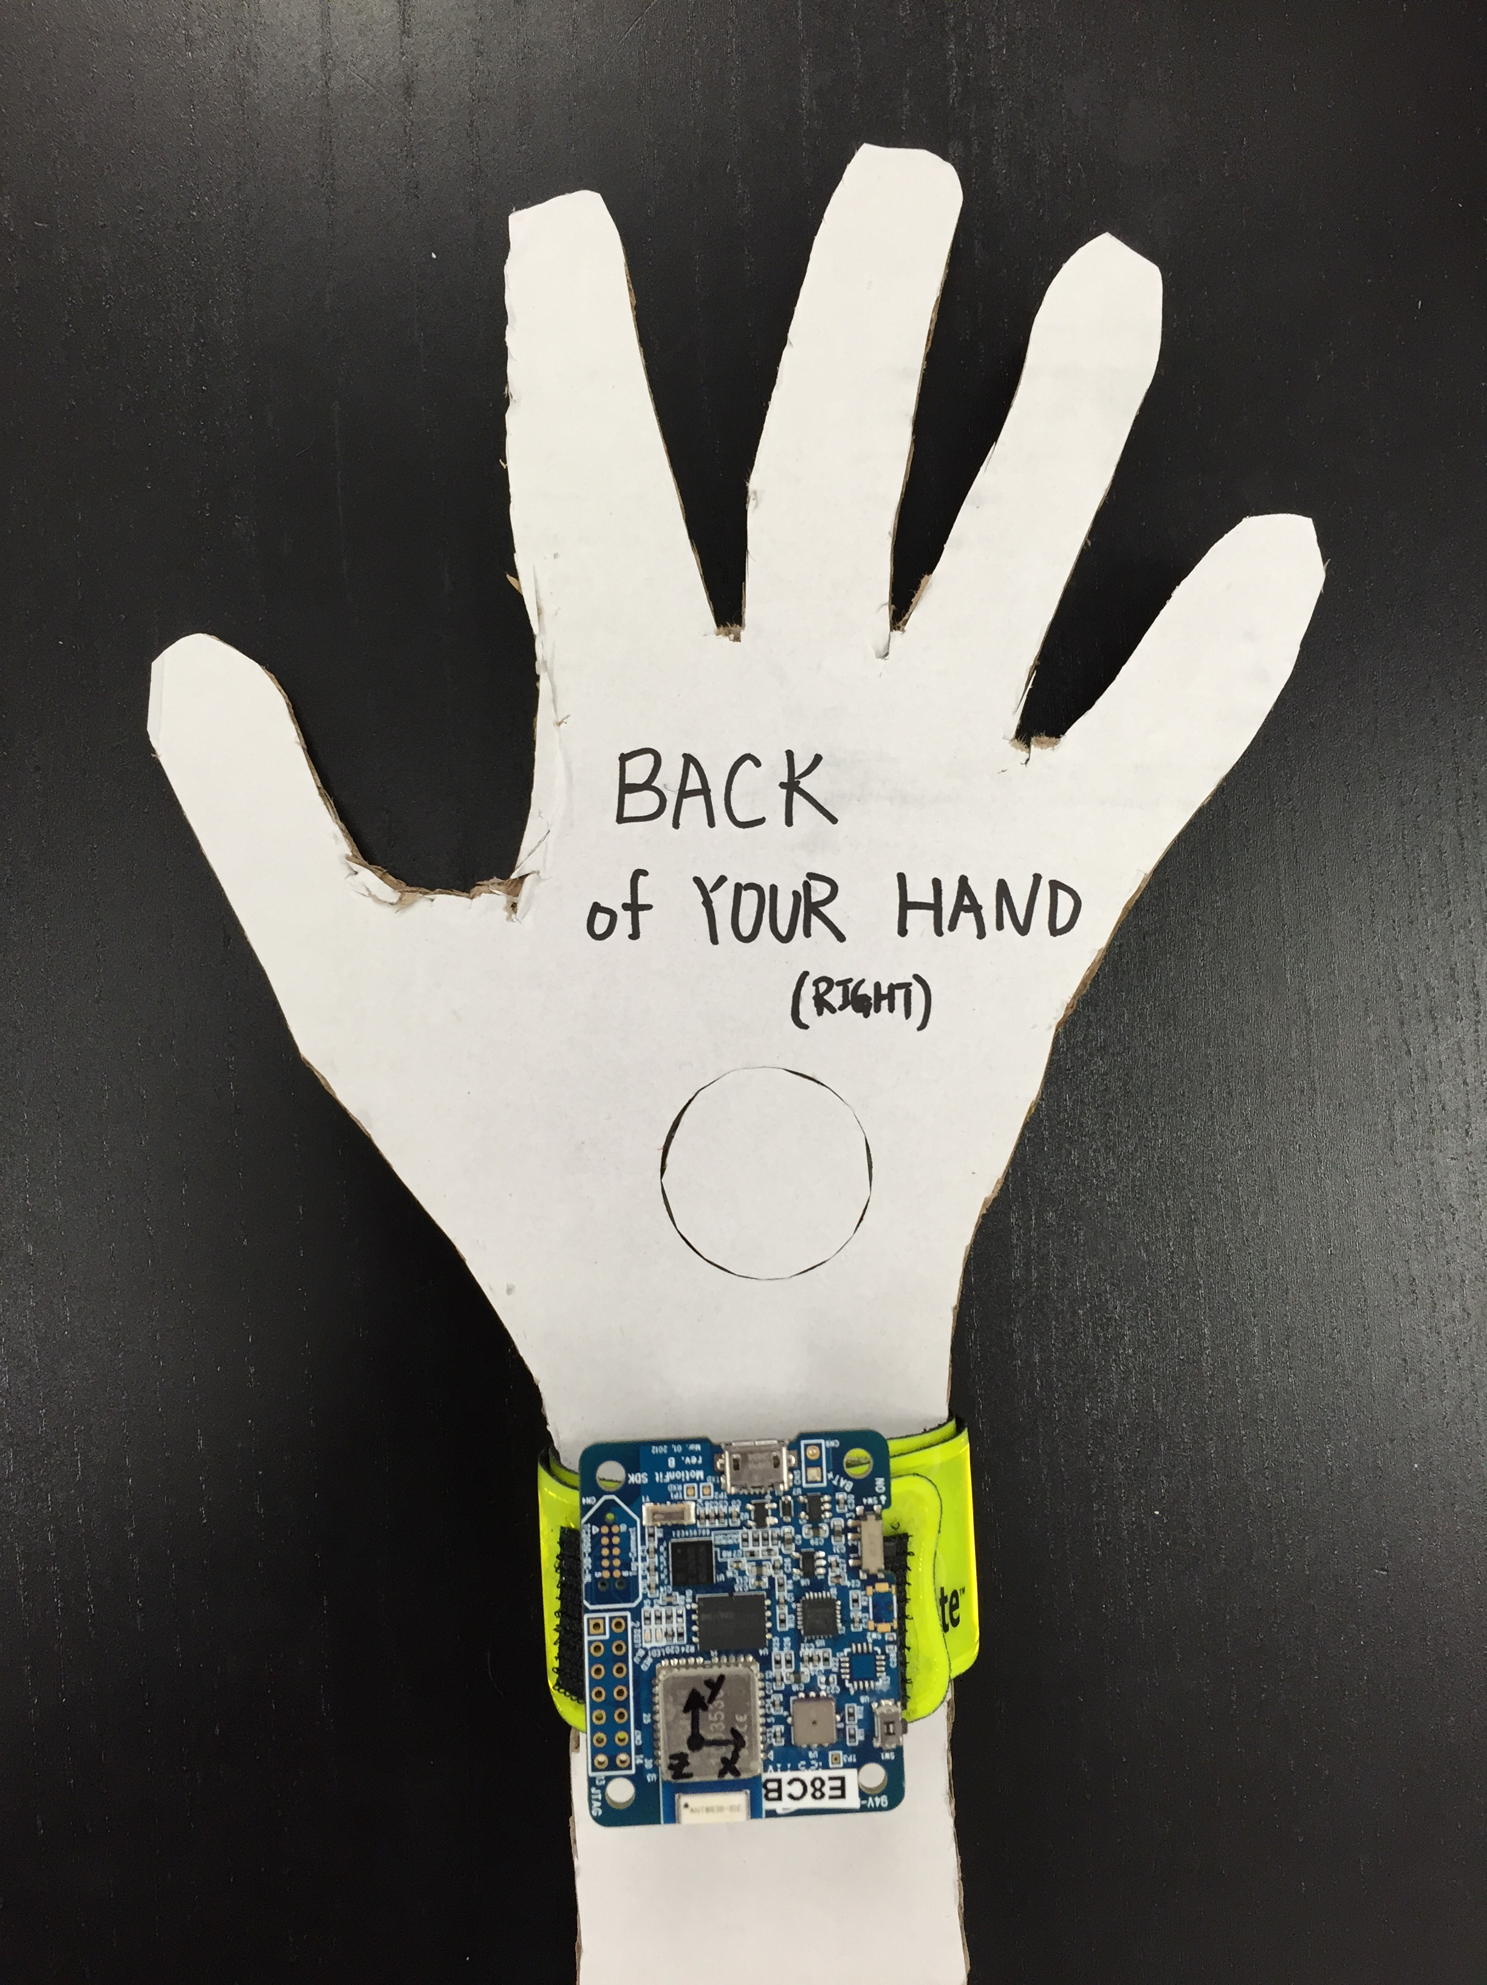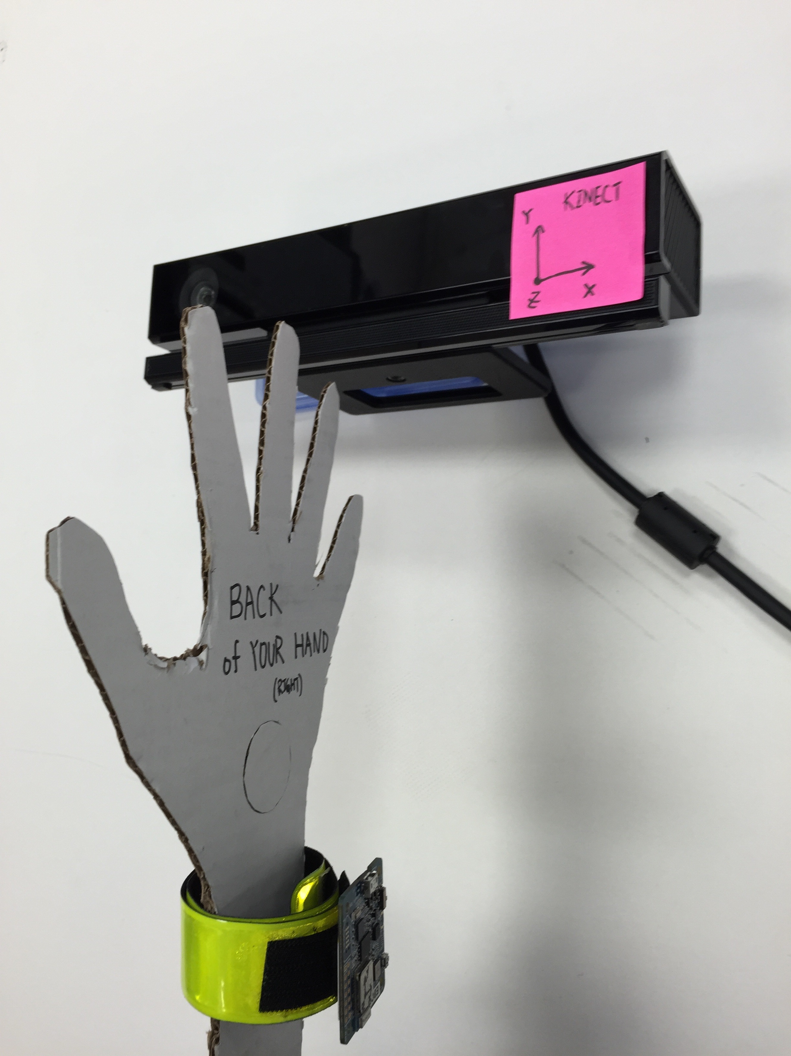  
      
      
    **Figure 2&3. Correct Orientation of Right Arm Binding**
* Create/View Kinect Virtual Sensor
  + Connect a Bluetooth device.
  + Once the Bluetooth device appears in the box at the bottom, click the drop down list under the *Sensor Location* column and select the correct joint (usually right forearm)
  + 2 more graphs will pop up, as well as 2 more devices at the bottom boxes. These graphs and rows can be used to understand how the Kinect is seeing the joint.

Two main tasks

* **Task 1: Attempt a linier and rotational calibration (Find the angles and displacement)**
  + Connect to a Bluetooth device.
  + Put device on the right forearm (not necessary to be the correct orientation)
  + At the box in the bottom, under the column *Sensor Location* locate the connected Bluetooth device and select *Forearm right*
  + Get into the view of the Kinect, ensure that oneself can be seen with either of a Kinect visualizers. Once in the frame, press Setup Calibrator.
  + Once the bar goes green, press calibrate after one feels there is 10 seconds of good data.
  + (Just because the bar is green doesn’t mean that the data is good)
* **Task 2: Seeing the difference between the Kinect and Inertial Sensor of the quaternion**
  + Connect to a Bluetooth device
  + Put device on the right forearm
  + Once the Bluetooth device appears in the box at the bottom, click the drop down list under the *Sensor Location* column and select the correct joint (usually right forearm)
  + Put the wrist in the identity orientation (Right hand pointed to the ceiling, hand open, thumb away from Kinect)
  + When the device is in the correct orientation, press <Bind To Right Forearm>
  + At this point you are free to move to any other orientation.
  + Once in another *good* orientation, press *calibrate like frames*.
  + After 5 second of data reads, the correction will be out put
  + NOTE: you must stay in the frame during the calibration.
  + NOTE: the results should be <5% error, if they are greater you didn’t bind to the Right Forearm while in the identity position.
  + NOTE: This test can only check the difference between the Kinect’s quaternion calculations vs. the sensors.